Terraform Resource Provisioning

1. Dedicated folder for Dev, Stage and Prod are created
2. Each of the folder is having main.tf file to create the resource for that env.
3. Go to each folder and run
   1. az login #to login to Azure portal
   2. then run terraform init
   3. followed by terraform apply
4. Ran the same the below resource group and Mysql Dbs are created

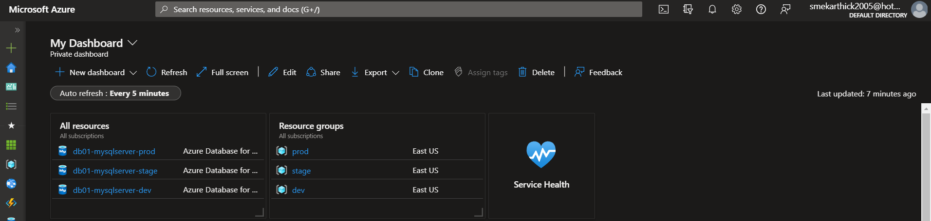

Package the docker file

Run Docker build in the src folder to get the code ready

Install Prometheus and Grafana

using Bash script with Helm commands in them.

We could see the data flowing in the promql and the graphs are getting populated.

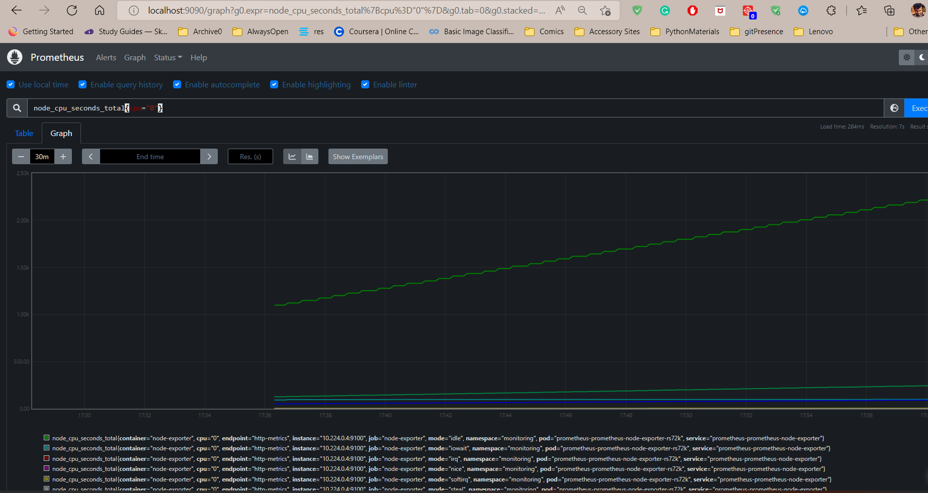

Click create new alerts and then create new alerts.

You can either use the query builder or use PromQL

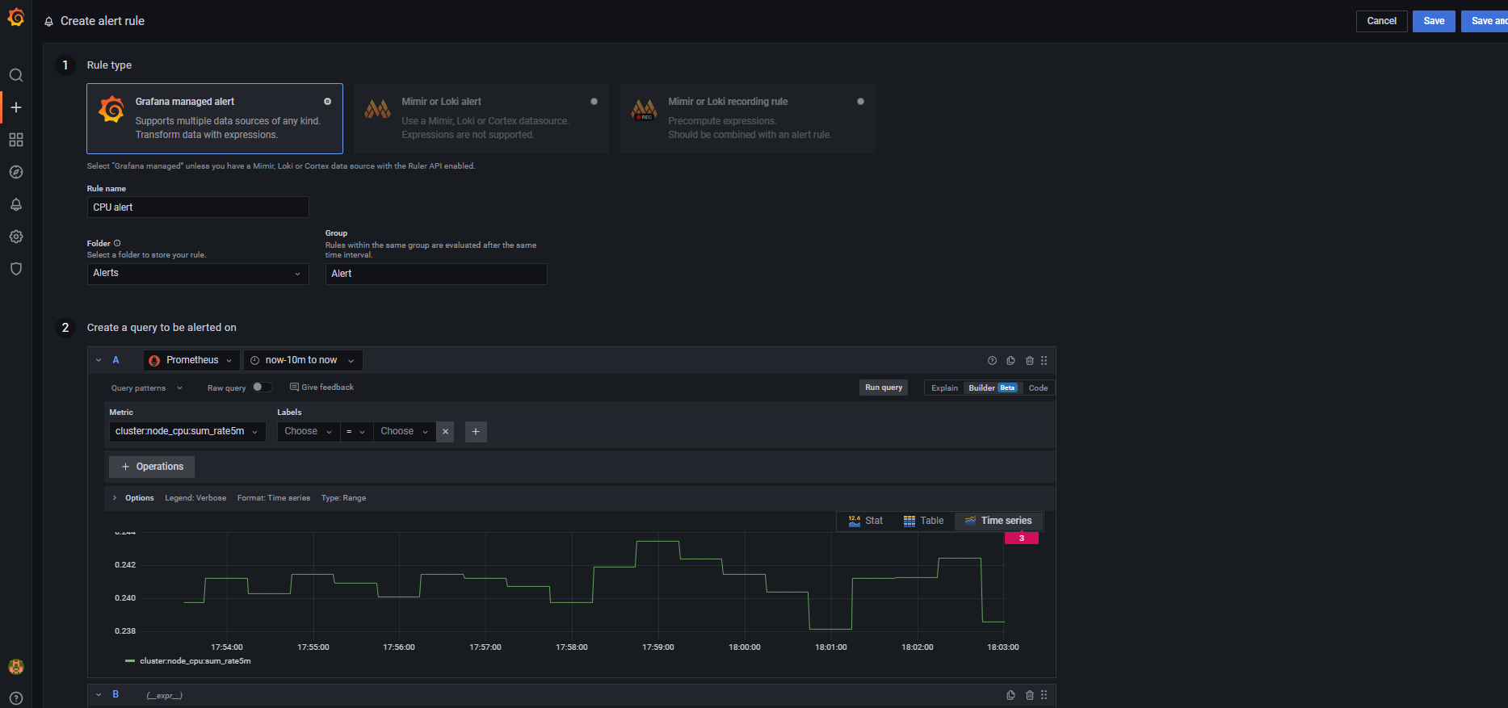

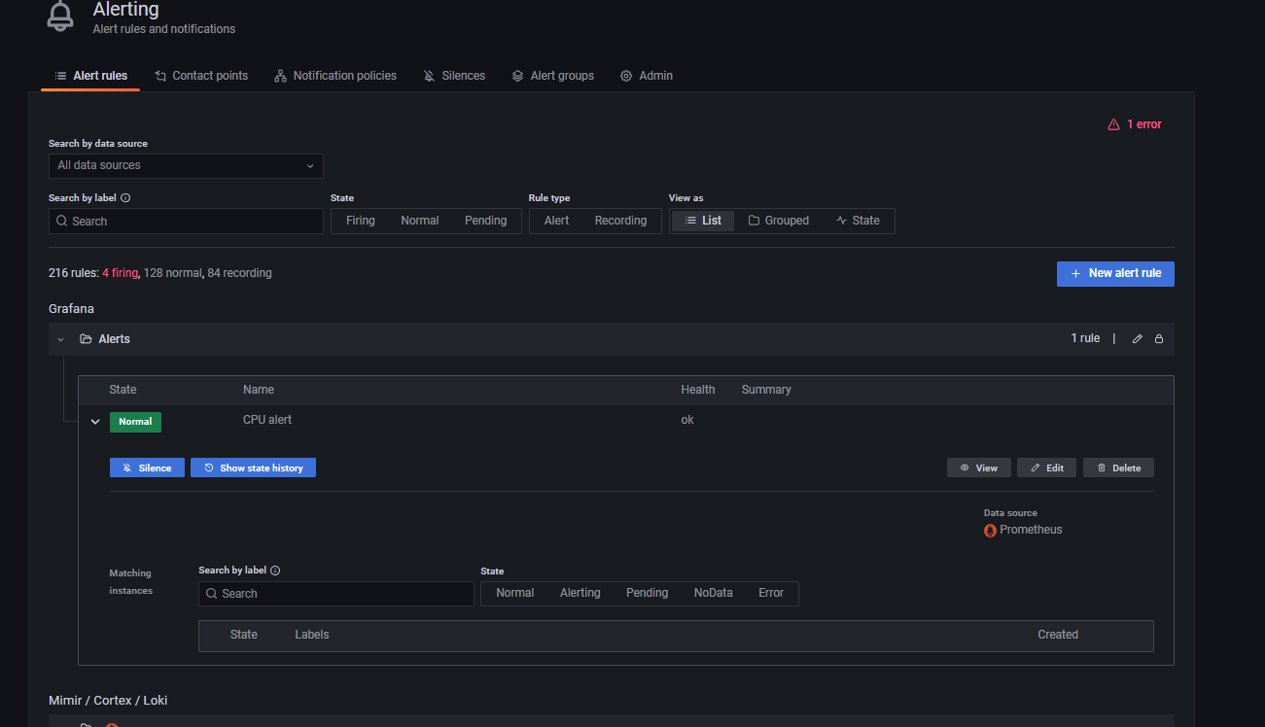

CI/CD pipeline:

A single build and release pipeline is created.

https://dev.azure.com/KartCorp/Assesment/_build

Steps performed by the pipeline:

1. Performs build of the python code to a docker image
2. Push the image to Docker hub
3. Connect to the Docker hub and deply the continer as a pod to the kuberntes cluster.